Spring Workers Synchronization Problem Report

Problem Statement
Simulate a tree containing fruits. Three picker workers and one loader worker operate in parallel.
- Pickers collect fruits from the tree.
- Pickers place fruits into a crate having 12 slots.
- When the crate becomes full, the loader loads the crate into a truck.
- After loading, the loader provides an empty crate again.
- Every fruit must be picked exactly once.
- When the tree becomes empty, pickers terminate.
- At the end, if a partially filled crate exists, the loader also loads it into the truck.
The system must be synchronized correctly to avoid race conditions and deadlocks.

Technologies Used
- Programming Language: Python
- Module Used: threading
- Synchronization Tools:
  - Lock
  - Semaphore

Conceptual Overview
The project consists of the following components:

1. Tree
The tree is represented as a shared list containing fruits.
Example:
tree = [1, 2, 3, ..., 30]
Each number represents a fruit.
Only one picker can access the tree at a time. Each picker randomly selects one available fruit from the remaining fruits in the tree.

2. Crate
The crate is a temporary storage area where pickers place fruits.
- Maximum capacity = 12 fruits
- Shared among all pickers
- Must be synchronized properly

3. Truck
The truck stores all loaded crates.
Whenever the loader loads a crate, that crate is appended into the truck.

4. Picker Threads
Three picker threads run simultaneously.
Responsibilities of a picker:
- Pick fruit from the tree.
- Wait if the crate is full.
- Put fruit into the crate.
- Signal the loader if the crate becomes full.
- Stop when the tree becomes empty.

5. Loader Thread
The loader thread works in parallel with the pickers.
Responsibilities of the loader:
- Wait until the crate becomes full.
- Load the crate into the truck.
- Empty the crate.
- Provide space for pickers again.
- Load the final partially filled crate.
- Terminate after all work is completed.

Synchronization Mechanisms
This project uses locks and semaphores for synchronization.

Locks Used

1. mutex_tree
mutex_tree = threading.Lock()
Purpose:
- Protects the shared tree.
- Ensures only one picker accesses the tree at a time.
- Prevents multiple pickers from picking the same fruit.
Without this lock:
- Two pickers could remove the same fruit.
- Race conditions could occur.

2. mutex_crate
mutex_crate = threading.Lock()
Purpose:
- Protects the shared crate.
- Ensures safe insertion and removal of fruits.
- Prevents corruption of crate data.
Without this lock:
- Multiple pickers could modify the crate simultaneously.
- Loader and pickers could conflict.

Semaphores Used

1. crate_empty
crate_empty = threading.Semaphore(CRATE_SIZE)
Initial value = 12
Purpose:
- Represents available empty slots in the crate.
- Prevents overflow of the crate.
Working:
- Picker performs acquire() before adding fruit.
- Loader performs release() after emptying crate.

2. crate_full
crate_full = threading.Semaphore(0)
Initial value = 0
Purpose:
- Used as a signal for the loader.
- Indicates that the crate is full.
Working:
- Picker performs release() when crate becomes full.
- Loader performs acquire() and waits for signal.

Deadlock Prevention
Special care was taken to avoid deadlocks.
The following rules were followed:
- Locks are held only for short durations.
- No thread waits on a semaphore while holding another lock.
- Locks are acquired in a consistent order.
- Shared resources are separated properly.
Because of these precautions, the system operates safely.

Race Condition Prevention
Race conditions occur when multiple threads modify shared data simultaneously.
This project prevents race conditions by:
- Protecting tree operations using mutex_tree.
- Protecting crate operations using mutex_crate.
- Controlling crate capacity using semaphores.
Thus:
- Each fruit is picked only once.
- Crate capacity never exceeds 12.
- Loader and pickers operate safely.

Complete Source Code:
Initialization:
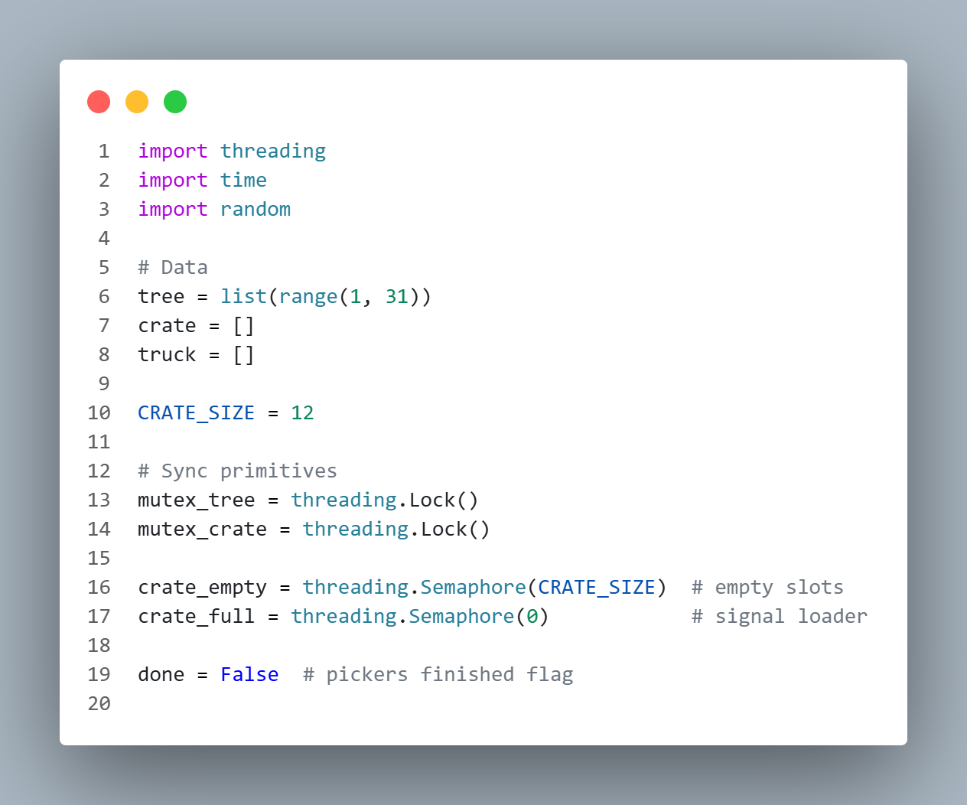
Picker:
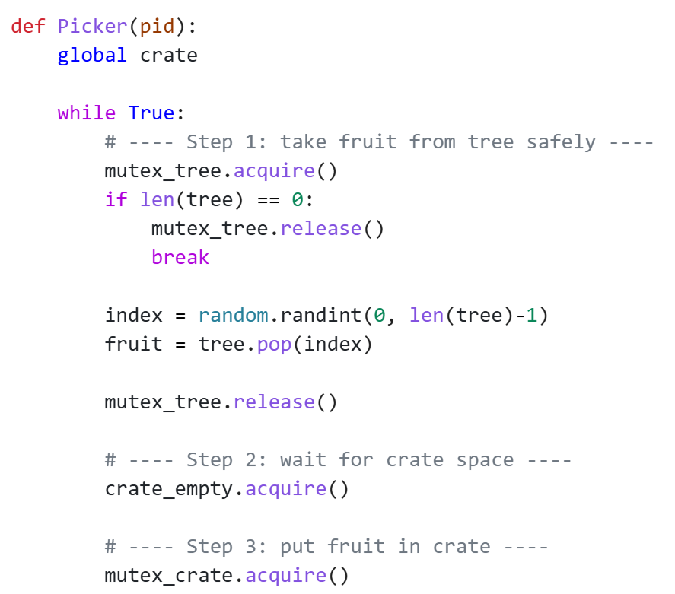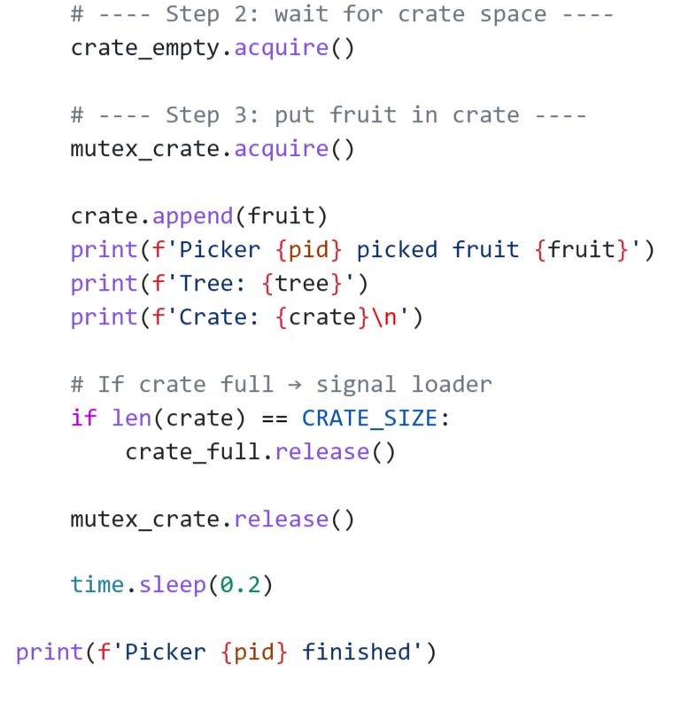

Loader:

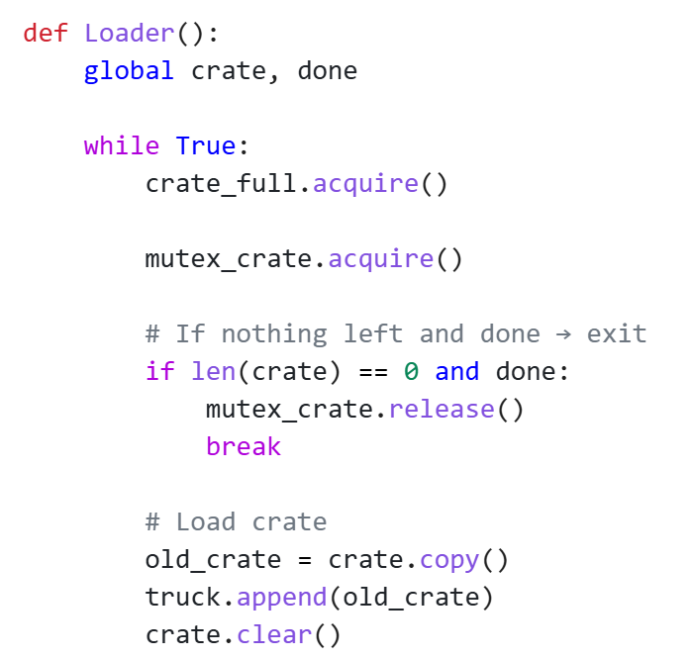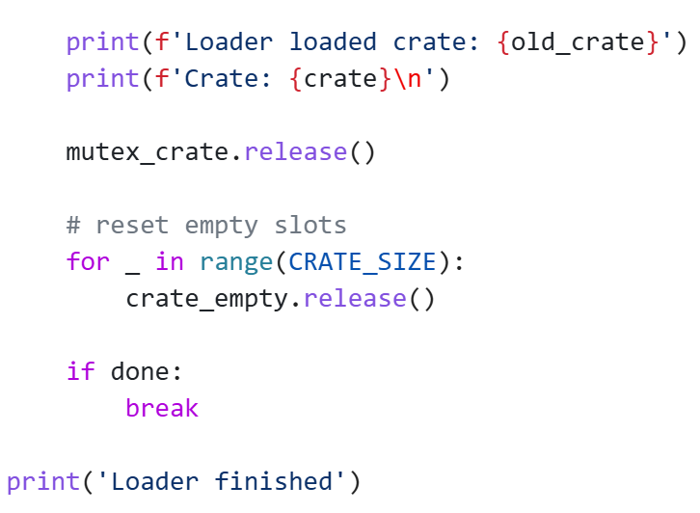
Main:
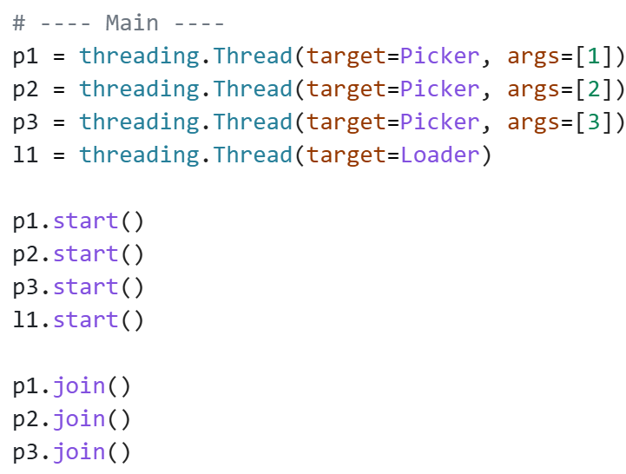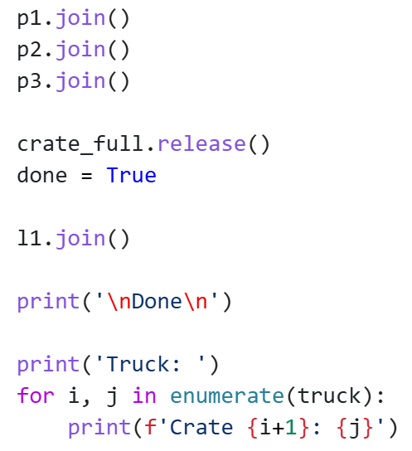

Working Explanation of the Program

Step 1: Initialization
The tree is filled with fruits from 1 to 30. Pickers select fruits randomly from the tree instead of following sequential order.
The crate and truck are initially empty.
Locks and semaphores are initialized.

Step 2: Picker Execution
Three picker threads start execution.
Each picker:
- Locks the tree.
- Randomly selects one fruit from the available fruits.
- Removes the selected fruit from the tree.
- Unlocks the tree.
- Waits for empty crate slot.
- Locks the crate.
- Places fruit in crate.
- Unlocks the crate.
- Signals loader if crate becomes full.

Step 3: Loader Execution
Loader waits until crate_full semaphore is signaled.
After receiving signal:
- Loader locks the crate.
- Copies crate into truck.
- Clears crate.
- Unlocks crate.
- Releases crate slots.

Step 4: Final Crate Handling
When all pickers finish:
done = True
crate_full.release()
This ensures that the loader wakes up and loads any partially filled crate.

Code Output:
1.
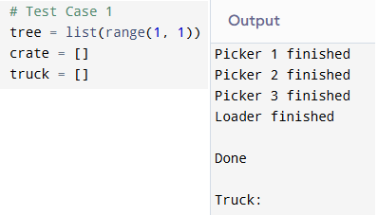
2. Output:
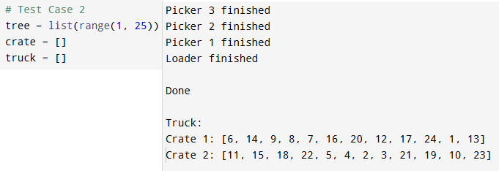
3. Output:
